EX : 3 Linear Regression using Time Series Data
AIM:
To implement the linear regression using the time series data
CODE:
import numpy as np
import pandas as pd
from pathlib import Path
%matplotlib inline
# Currency pair exchange rates for CAD/JPY
cad_jpy_df = pd.read_csv(
Path("cad_jpy.csv"), index_col="Date", infer_datetime_format=True, parse_dates=True
)
cad_jpy_df.head()
# Trim the dataset to begin on January 1st, 1990
cad_jpy_df = cad_jpy_df.loc["1990-01-01":, :]
cad_jpy_df.head()
# Create a series using "Price" percentage returns, drop any nan"s, and check the results:
# (Make sure to multiply the pct_change() results by 100)
# In this case, you may have to replace inf, -inf values with np.nan"s

cad_jpy_df['Return'] = (cad_jpy_df[["Price"]].pct_change() * 100)
returns = cad_jpy_df.replace(-np.inf, np.nan).dropna()
returns.tail()
# Create a lagged return using the shift function
cad_jpy_df['Lagged_Return'] = cad_jpy_df["Return"].shift()
cad_jpy_df = cad_jpy_df.dropna()
cad_jpy_df.tail()
# Create a train/test split for the data using 2018-2019 for testing and the rest for training
train = cad_jpy_df[:'2018']
test = cad_jpy_df['2018':]
# Create a Linear Regression model and fit it to the training data
from sklearn.linear_model import LinearRegression

# Fit a SKLearn linear regression using just the training set (X_train, Y_train):
model = LinearRegression()
model.fit(x_train, y_train)
# Make a prediction of "y" values using just the test dataset
predictions = model.predict(x_test)
# Assemble actual y data (Y_test) with predicted y data (from just above) into two columns in a dataframe:
results = y_test.to_frame()
results["Predicted Return"] = predictions
results.head(2)
# Plot the first 20 predictions vs the true values
results[:20].plot(subplots=True, figsize = (10, 10))
output:
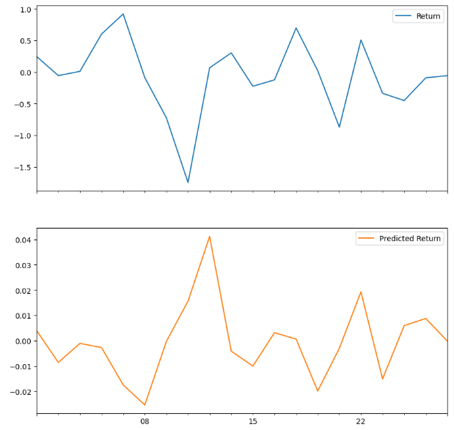
Result:
Thus the implementation of linear regression using time series data has bee done

